**BigQuery Open Data Set Queries**

* What is the handwritten code on your assignment?

AC

* For each query (1-3), paste your SQL query and the results (one screen shot showing a few rows of data, how many GB processed, and elapsed time.)

1.

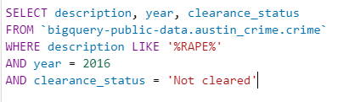

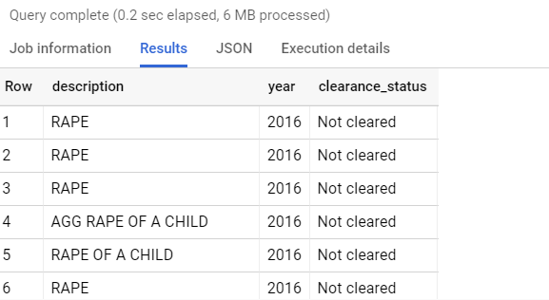

2.

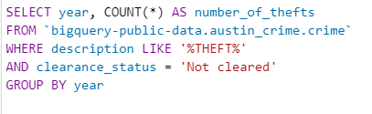

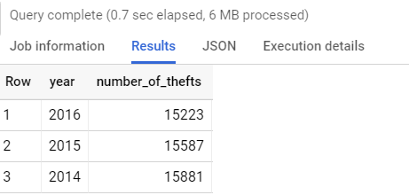

3.

